CRUISE CONTROL

software requirements

**Authors** Requirements Team

**Last Update** November 15th, 2013

**Summary:**

This document defines requirements of a cruise control system for an automatic transmission car.

***Table Of Contents***

1. Introduction 3

2. Cruise Control Requirements 3

2.1 Interface 3

2.2 Cruise Control behavior 4

2.3 Car driving control 5

2.4 Cruise speed management 5

2.5 Pedals pressed detection 6

2.6 Cruise Control parameters 6

# Introduction

The Cruise control is a system to automatically control the speed of a car. The driver sets the speed and the system will take over the throttle of the car to maintain the same speed.

# Cruise Control Requirements

## Interface

The Cruise Control (CC) should connect to the system using the following inputs.

CC_HLR_IN_01

On: Enable the CC

CC_HLR_IN_02

Off: Disable the CC

CC_HLR_IN_03

Resume: Resume the CC after a braking

CC_HLR_IN_04

Set: Set the current speed as the new cruise speed

CC_HLR_IN_05

QuickDecel: Decrease the cruise speed

CC_HLR_IN_06

QuickAccel: Increase the cruise speed

CC_HLR_IN_07

Accel: Accelerator pedal sensor

CC_HLR_IN_08

Brake: Brake pedal sensor

CC_HLR_IN_09

Speed: Car speed sensor

And the CC should deliver the followings outputs.

CC_HLR_OUT_01

CruiseSpeed: Cruise speed value

CC_HLR_OUT_02

ThrottleCmd: Throttle command

CC_HLR_OUT_03

CruiseState: this is the state of the CC. It can be OFF, ON, STDBY, INT.

The following diagram resumes the CC interface:

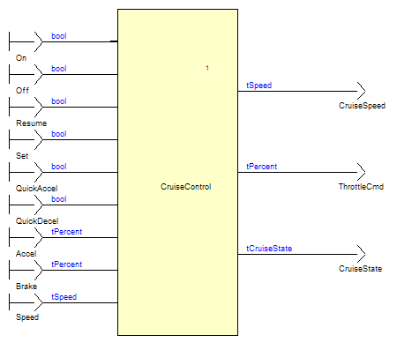

## Cruise Control behavior

CC_HLR_CCB_01

When the driver starts the car, the CC shall be off.

The output CruiseState should be set to OFF

CC_HLR_CCB_02

The CC shall be set on when the driver push the on button.

CC_HLR_CCB_03

The CC shall automatically go off when the off button is pressed.

CC_HLR_CCB_04

If the car speed is in the speed limit and the accelerator pedal is not pressed, the CC shall be on and regulate the car speed.

The output CruiseState shall be set to ON.

CC_HLR_CCB_05

The CC system shall be automatically disabled when the accelerator pedal is pressed, or the car speed is outside the speed limit.

The output CruiseState shall be set to STDBY.

CC_HLR_CCB_06

The system shall return to the ON state when both the accelerator pedal is not pressed, and the car speed is inside the speed limit.

The last set cruise speed shall be re-used.

CC_HLR_CCB_07

The CC shall be immediately interrupted when the brake is pressed.

The output CruiseState shall be set to INT.

CC_HLR_CCB_08

The system shall resume either to the ON or STDBY states, depending on the Accelerator pedal and the Speed value when the resume button is pressed. The last set cruise speed shall be re-used.

## Car driving control

CC_HLR_CDC_01

When the CC is off, the car speed shall be driven using the accelerator pedal.

CC_HLR_CDC_02

When the CC is on, the car speed shall be automatically regulated.

CC_HLR_CDC_03

The regulation shall be done using a proportional and integral algorithm, with Kp and Ki factors.

CC_HLR_CDC_04

The regulation algorithm shall be protected against the overshoot of its integral part: the integral action shall be reset when the CC is going on, and frozen when the throttle output is saturated.

CC_HLR_CDC_05

The throttle command shall be saturated at ThrottleSatMax when automatically regulating, in order to limit the car acceleration for the comfort.

## Cruise speed management

CC_HLR_CSM_01

The Cruise Speed shall be managed only when the cruise control is enabled, meaning ON, STDBY, or INT states.

CC_HLR_CSM_02

The cruise speed shall be set to the current speed when the set button is pressed.

CC_HLR_CSM_03

The cruise speed shall be increased of SpeedInc km/h when the QUICKACCEL button is pressed.

only if this new value of the cruise speed is still lower than the maximal speed SpeedMax km/h.

CC_HLR_CSM_04

The cruise speed shall be decreased of SpeedInc km/h when the QUICKDECEL button is pressed.

CC_HLR_CSM_05

The Cruise Speed shall be maintained between SpeedMin and SpeedMax km/h values.

## Pedals pressed detection

CC_HLR_PPD_01

The accelerator pedal shall be detected as pressed when its value is above PedalsMin.

CC_HLR_PPD_02

The Brake pedal shall be detected as pressed when its value is above PedalsMin.

## Cruise Control parameters

CC_HLR_CCP_01

SpeedMin: 30.0 Km/h

CC_HLR_CCP_02

SpeedMax: 150.0 Km/h

CC_HLR_CCP_03

SpeedInc: 2.5 Km/h

CC_HLR_CCP_04

Kp: 8.113

CC_HLR_CCP_05

Ki: 0.5

CC_HLR_CCP_06

ThrottleSatMax: 45.0 percent

CC_HLR_CCP_07

PedalsMin: 3.0 percent.